Comparative Analysis of Deep Learning Models for IoT Intrusion Detection Using CICIoT2023
Deep Learning Project Report
Name: Namrata Kothari
Registration Number: 2430010345

1. Abstract
This project presents a controlled comparative study of seven deep learning models for multiclass IoT intrusion detection using the CICIoT2023 dataset. The study evaluates a baseline Deep Neural Network (DNN), DNN with Dropout, DNN with L2 regularization, a proposed regularized DNN combining Dropout, L2 regularization and Batch Normalization, a 1D Convolutional Neural Network (CNN), an LSTM model, and a Transformer. To reduce the effect of the highly imbalanced training distribution, a class-balanced training pool was created after duplicate removal, while the original test distribution was retained for realistic evaluation. Models were evaluated using accuracy, macro precision, macro recall, macro F1, macro specificity, confusion matrices and training time. The study also compares the architectures under a common experimental protocol and places the results in context with published CICIoT2023 studies. The later addition of the Transformer extends the comparison to an attention-based architecture and enables analysis of its predictive performance versus computational cost.

2. Problem Statement
IoT networks generate large volumes of heterogeneous traffic and are exposed to diverse cyberattacks. Deep learning can learn complex traffic patterns, but model performance is affected by class imbalance, preprocessing choices, architecture selection and computational cost. This project investigates whether carefully regularized deep learning models can provide useful multiclass intrusion detection performance on CICIoT2023 and whether different DL architectures offer meaningful trade-offs.

3. Objectives
- Analyze the class distribution and data quality of CICIoT2023.
- Build a reproducible preprocessing pipeline using numerical flow features.
- Implement and compare seven representative deep learning architectures, including DNN variants, 1D CNN, LSTM and Transformer.
- Study the effect of Dropout, L2 regularization and Batch Normalization through ablation-style comparisons and compare them with the later-added Transformer.
- Evaluate models using class-aware metrics rather than accuracy alone.
- Compare the obtained results with published CICIoT2023 studies while explicitly accounting for differences in experimental protocols.
- Analyze computational cost and document limitations and future work.

4. Dataset Analysis
The experiment uses the 8-class grouped version of CICIoT2023. The working training file contains 1,073,851 rows and 42 columns. The 42 columns consist of 39 numerical network-flow features and three label representations: the grouped attack class, the fine-grained label and the binary label. The test file contains 268,463 rows.
Class | Training Samples | Approx. %
DDoS | 361,842 | 33.70
Recon | 161,877 | 15.07
Benign | 159,990 | 14.90
DoS | 159,925 | 14.89
Mirai | 119,897 | 11.17
Spoofing | 80,043 | 7.45
Web-based | 19,820 | 1.85
BruteForce | 10,457 | 0.97
No missing values were found. The original training split contained 84,370 exact duplicate rows. After duplicate removal, 989,481 rows remained. A balanced pool of 10,000 samples per class was then formed, producing 80,000 samples. This pool was divided into 64,000 training and 16,000 validation samples using stratification. The held-out test set was kept in its original imbalanced distribution.

5. Preprocessing
- Remove exact duplicate rows from the training data.
- Remove attack_class, Label and label from the model input to prevent target leakage.
- Retain only the 39 numerical network-flow features.
- Encode the eight grouped attack classes.
- Use a stratified 80/20 train-validation split.
- Fit StandardScaler only on the training data and apply the same transformation to validation and test data.
Target leakage was explicitly avoided: the binary label and fine-grained label are not included as input features. This is important because the dataset contains multiple label representations.

6. Models and Experimental Design
Model | Architecture / Modification
DNN | 39 → 128 → 64 → 32 → 8; ReLU hidden layers
DNN + Dropout | Baseline DNN + 0.30 Dropout after first two hidden layers
DNN + L2 | Baseline DNN + L2(0.001) on first two dense layers
Proposed DNN | L2 + Batch Normalization + Dropout + EarlyStopping + ReduceLROnPlateau
1D CNN | Conv1D(64) → BN → Pool → Conv1D(128) → Pool → Dense(128) → Dropout
LSTM | LSTM(64) → Dropout → LSTM(32) → Dropout → Dense(64)
Transformer | Feature tokens → positional embedding → self-attention/Transformer block → pooling → dense classifier
All seven models use the same core multiclass classification setting for controlled comparison. The evaluated architectures are DNN, DNN + Dropout, DNN + L2, Proposed DNN, 1D CNN, LSTM and Transformer. The main models use Adam optimization, sparse categorical cross-entropy and batch size 256, with a maximum training budget of 20 epochs. The proposed DNN additionally uses EarlyStopping with restore_best_weights and ReduceLROnPlateau. The Transformer extends the comparison with an attention-based architecture operating on the 39 input features.
Transformer addition: The Transformer was added in the later experimental stage to extend the comparison beyond feed-forward, convolutional and recurrent architectures. Its attention-based design provides a useful contrast with the CNN/LSTM models, while the results also expose its computational cost under the present setup.

Evaluation Metrics
Metric | Interpretation | Importance for IDS
Accuracy | Fraction of all predictions that are correct | Useful overall measure but sensitive to imbalance
Precision | Correct positive predictions among predicted positives | Helps assess false-alarm behaviour
Recall | Correctly detected positives among actual positives | Important for detecting attacks
F1 score | Harmonic mean of precision and recall | Balances missed attacks and false alarms
Specificity | Correct recognition of negative/non-target cases | Useful for benign traffic recognition
Training time | Time needed to train the model | Indicates computational cost and scalability

7. Literature Review
The literature review was expanded beyond three papers because CICIoT2023 research includes several different directions: foundational benchmarking, conventional ML, DNN/CNN/LSTM models, hybrid models, explainable IDS, federated learning, real-time detection and efficiency-oriented approaches. Published results are not all directly comparable because studies use different class definitions, preprocessing, sampling, train-test splits and evaluation protocols.
Study | Year | Dataset | Approach | Reported Finding / Relevance
Neto et al. – CICIoT2023 Benchmark | 2023 | CICIoT2023 | RF, DNN, MLP, LR, AdaBoost | Foundational benchmark; very strong reported accuracy; highlights scale and imbalance.
Wang et al. / DL-BiLSTM | 2023 | CICIoT2023 | DNN, CNN, RNN/BiLSTM family | Reported multiclass performance around 93%; useful DL reference.
Yaras & Dener | 2024 | CICIoT2023 + TON_IoT | CNN, LSTM, CNN-LSTM + ML | Reported 99.995% binary and 99.96% multiclass; protocol differs from this study.
Becerra-Suarez et al. | 2024 | CICIoT2023 | DNN, CNN, LSTM | CNN reported about 99.10% multiclass; directly relevant DL comparison.
Ahmad et al. | 2025 | CICIoT2023 | Extra Trees + GRU + SHAP | 97.56% multiclass; demonstrates modern DL + explainability.
Federated XAI IDS | 2025 | CICIoT2023 | ANN + FedAvg + SHAP | About 88.2% testing accuracy; adds federated complexity.
Erskine – Real-Time Large-Scale IDPS | 2025 | CICIoT2023 | ANN, CNN, RNN, MLP | >85% accuracy and high precision; emphasizes real-time IDS.
Explainable AI-Driven IDS Framework | 2026 | CICIoT2023 + IoT-23 | DT, RF, XGBoost, CNN, LSTM, Transformer + SHAP/LIME | Unified ML/DL/XAI direction and efficiency considerations.
Optimized Gradient Boosting Framework | 2026 | CICIoT2023 | XGBoost, LightGBM, CatBoost | Feature selection and inference-latency oriented direction.
These studies establish that CICIoT2023 has already been extensively investigated. Therefore, the present project does not claim to introduce the first DL model or the first IDS on this dataset. Instead, it focuses on a controlled comparison and ablation study under a common preprocessing and evaluation pipeline.

8. SOTA Comparison
The following comparison is contextual rather than a strict head-to-head benchmark. Published studies use different datasets subsets, class definitions, balancing methods and experimental settings. Consequently, the external values should not be interpreted as directly reproducible under the present protocol.
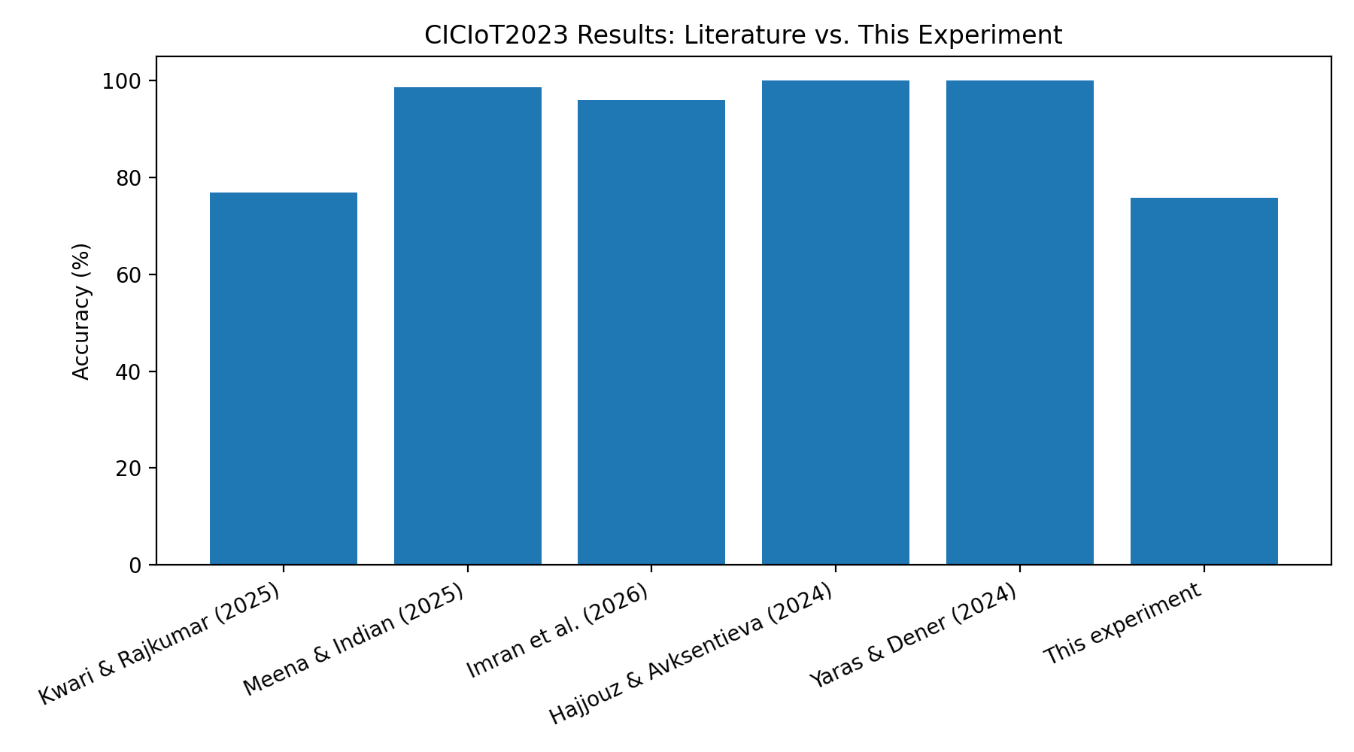
Figure 3. Comparison with selected literature results supplied for the project.
Study / Model | Task | Reported Accuracy | Comparison Note
Neto et al. DNN | 8-class / grouped | ≈99.11% | Foundational benchmark; experimental setup differs.
Neto et al. RF | 8-class / grouped | ≈99.43% | Traditional ML benchmark; not a DL model.
Yaras & Dener hybrid DL | Multiclass | ≈99.96% | Hybrid CNN-LSTM/ML setting; preprocessing differs.
Becerra-Suarez et al. CNN | Multiclass | ≈99.10% | Closest published DL reference, but protocol differs.
Wang et al. DL-BiLSTM | Multiclass | ≈93.13% | Sequence-based architecture; different experimental setup.
Ahmad et al. XGRU-IDS | 34-class multiclass | 97.56% | Uses Extra Trees + GRU + SHAP and all fine-grained classes.
Our DNN | 8-class | 75.30% | Common preprocessing and original imbalanced test set.
Our 1D CNN | 8-class | 75.74% | Highest predictive performance in our controlled experiment.
Our Transformer | 8-class | 63.90% | Attention-based model; substantially higher training cost in this setup.
The lower accuracy of the present experiment should not be interpreted as evidence that the published studies are incorrect. The current experiment deliberately uses a 10,000-per-class training pool and retains the original imbalanced test distribution, while several published studies use different subsets, balancing strategies or classification definitions. The value of the present comparison is therefore the controlled internal comparison among our models.

9. Research Gap
Existing CICIoT2023 studies report strong performance using machine learning, deep learning, hybrid, federated and explainable approaches. However, the studies use different preprocessing techniques, class definitions, sampling strategies and evaluation settings, which makes direct comparison difficult. In addition, many studies emphasize overall accuracy, while class-wise performance, model complexity and computational cost are not consistently considered together.
A second gap is the treatment of class imbalance. High overall accuracy can hide weak performance on minority attack categories such as BruteForce and Web-based attacks. This motivates macro-level metrics and explicit analysis of minority-class recall and F1.
The selected research gap for this project is therefore: a controlled and reproducible comparison of representative deep learning architectures on CICIoT2023 using the same preprocessing, class definition, split strategy and evaluation metrics, while explicitly examining class imbalance, regularization effects and computational cost.

10. Proposed Innovation / Contribution
- A common reproducible preprocessing and evaluation pipeline for seven representative DL models, including an attention-based Transformer.
- Ablation-style comparison of baseline DNN, Dropout, L2 regularization and the combined regularized DNN.
- Explicit use of macro precision, macro recall, macro-F1 and macro specificity in addition to accuracy.
- Training-time comparison to expose the accuracy-versus-computation trade-off.
- Analysis of minority attack classes rather than relying only on aggregate accuracy.
The proposed DNN did not outperform the baseline DNN in the final test evaluation. This negative result is retained because it provides evidence about the actual effect of the added regularization components under the chosen experimental setup.

11. Results
Model | Accuracy | Macro Precision | Macro Recall | Macro F1 | Macro Specificity | Time (s) | Params
DNN | 75.30% | 0.6474 | 0.6987 | 0.6349 | 0.9649 | 32.37 | 15,720
DNN + Dropout | 75.21% | 0.6389 | 0.6899 | 0.6265 | 0.9645 | 30.00 | 15,720
DNN + L2 | 73.88% | 0.6312 | 0.6956 | 0.6246 | 0.9630 | 27.66 | 15,720
Proposed DNN | 74.46% | 0.6442 | 0.6892 | 0.6235 | 0.9636 | 35.10 | 16,232
1D CNN | 75.74% | 0.6494 | 0.7049 | 0.6377 | 0.9655 | 305.55 | 157,448
LSTM | 54.58% | 0.4950 | 0.4881 | 0.4342 | 0.9358 | 240.64 | 31,944
Transformer | 63.90% | 0.5690 | 0.5593 | 0.5197 | 0.9485 | 889.91 | 157,448
The 1D CNN achieved the highest overall predictive performance with 75.74% accuracy and 63.77% macro-F1. The DNN followed closely at 75.30% accuracy and 63.49% macro-F1 while requiring only 32.37 seconds of training. The Transformer achieved 63.90% accuracy and 51.97% macro-F1 but required the highest training time at 889.91 seconds. The LSTM produced the weakest overall result. The minority classes BruteForce and Web-based remain substantially more difficult than the majority classes.
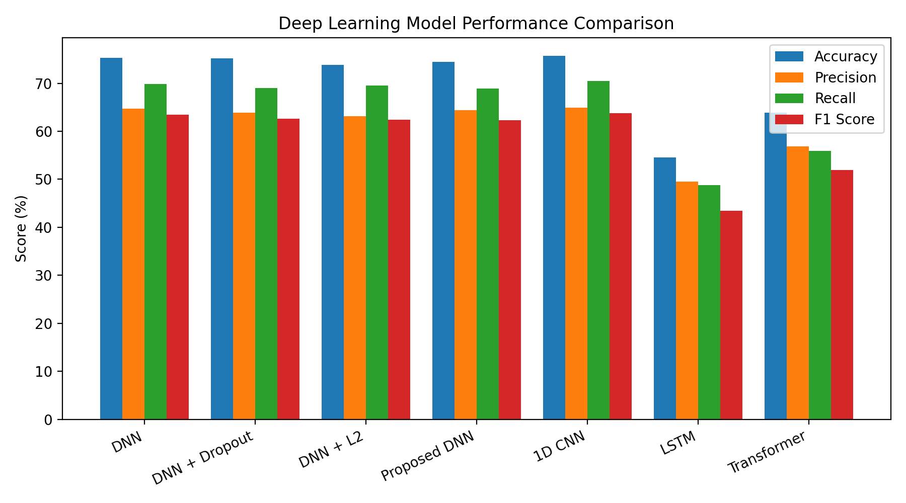
Figure 1. Model performance comparison from the supplied Transformer-enabled experiment.
Rank | Model | Accuracy | F1 | Training time (s)
1 | 1D CNN | 75.74% | 63.77% | 305.55
2 | DNN | 75.30% | 63.49% | 32.37
3 | DNN + Dropout | 75.21% | 62.65% | 30.00
4 | Proposed DNN | 74.46% | 62.35% | 35.10
5 | DNN + L2 | 73.88% | 62.46% | 27.66
6 | Transformer | 63.90% | 51.97% | 889.91
7 | LSTM | 54.58% | 43.42% | 240.64

12. Training and Generalization Analysis
The baseline DNN showed approximately 71.50% training accuracy and 70.09% validation accuracy at the reported checkpoint, giving a relatively small train-validation gap of about 1.41 percentage points. The learning curves therefore do not indicate severe overfitting in the baseline experiment. This also shows why overfitting alone is not treated as the project's innovation; the contribution is the controlled regularization and architecture comparison.
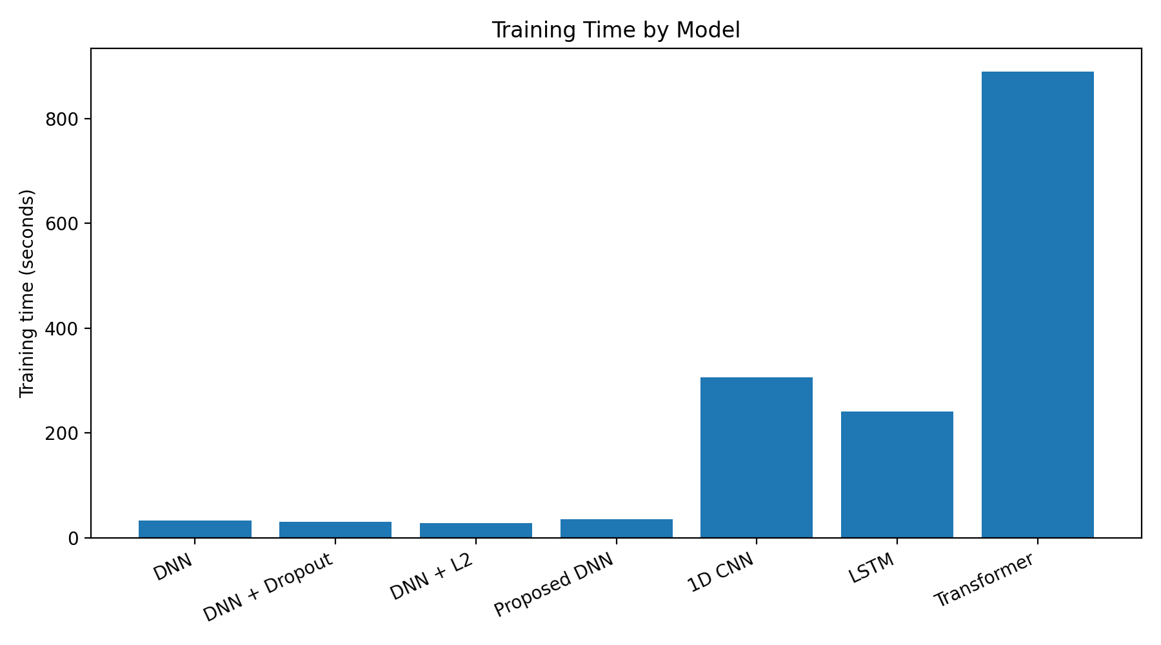
Figure 2. Training-time comparison of the seven evaluated architectures.

13. Limitations
- Only a computationally manageable 80,000-sample balanced training pool was used rather than the entire training split.
- The held-out test set remains imbalanced, so minority-class weaknesses remain visible and accuracy alone is insufficient.
- BruteForce and Web-based attacks remain difficult to classify reliably.
- Published SOTA results use different experimental protocols and are therefore contextual rather than strictly controlled comparisons.
- No exhaustive hyperparameter search or multiple-random-seed statistical validation was performed.
- The CNN and LSTM receive the 39 flow features as an ordered one-dimensional input even though these features are not a true temporal sequence, while the Transformer treats the features as tokens and therefore depends on the chosen feature ordering/embedding design.
- The project does not evaluate zero-day attacks, adversarial robustness or cross-dataset generalization.
- The models were not validated on live IoT traffic or edge hardware, so the experiment does not establish production readiness.
- Multiclass ROC-AUC is not included in the current saved results because the notebook retained hard class predictions rather than probability outputs.

14. Future Work
- Run probability-based multiclass ROC-AUC evaluation.
- Evaluate multiple random seeds and report mean ± standard deviation.
- Perform systematic hyperparameter optimization.
- Compare with a traditional ML baseline such as Random Forest under the exact same split.
- Investigate class-aware loss functions or focal loss for minority attacks.
- Use feature selection or dimensionality reduction to study efficiency.
- Evaluate explainability using SHAP/LIME as a separate extension.
- Test cross-dataset generalization and unseen/zero-day attack detection.
- Measure inference latency and deployment performance on resource-constrained IoT/edge hardware, with particular attention to the high training cost of attention-based models.

15. Conclusion
The project implemented and compared seven deep learning models for 8-class IoT intrusion detection on CICIoT2023 under a common preprocessing and evaluation pipeline. The 1D CNN achieved the highest predictive performance, while the DNN provided a strong accuracy–cost balance. The Transformer added an attention-based perspective but did not outperform the simpler architectures in this experiment and required substantially more training time. The proposed regularized DNN did not outperform the baseline, demonstrating that additional regularization is not automatically beneficial for every dataset and training configuration. The results highlight the importance of class-aware evaluation and computational-cost analysis, especially under class imbalance. The project is therefore positioned as a controlled comparative and ablation-based experimental study rather than a claim of a completely new IDS architecture.

16. References / Literature Base
- Neto, E. C. P., et al. (2023). CICIoT2023: A Real-Time Dataset and Benchmark for Large-Scale Attacks in IoT Environment. Sensors, 23(13), 5941. DOI: 10.3390/s23135941.
- Yaras, S., & Dener, M. (2024). IoT-Based Intrusion Detection System Using New Hybrid Deep Learning Algorithm. Electronics, 13(6), 1053. DOI: 10.3390/electronics13061053.
- Becerra-Suarez, F. L., Tuesta-Monteza, V. A., Mejia-Cabrera, H. I., & Arcila-Diaz, J. (2024). Performance Evaluation of Deep Learning Models for Classifying Cybersecurity Attacks in IoT Networks. Informatics, 11(2), 32. DOI: 10.3390/informatics11020032.
- Wang et al. (2023/2024). Deep-learning BiLSTM and related deep learning approaches evaluated on CICIoT2023.
- Ahmad, J., et al. (2025). An Interpretable Deep Learning Framework for Intrusion Detection in Industrial Internet of Things. Internet of Things, 33, 101681. DOI: 10.1016/j.iot.2025.101681.
- Federated XAI IDS study (2025), ANN + FedAvg + SHAP on CICIoT2023.
- Erskine (2025). Real-Time Large-Scale Intrusion Detection and Prevention System using CICIoT2023.
- Explainable AI-Driven IDS Framework for IoT Networks (2026), combining ML/DL and SHAP/LIME.
- Optimized Gradient Boosting Framework for CICIoT2023 (2026), emphasizing feature selection and inference efficiency.
- Additional studies and systematic-review material are included in the accompanying literature-review document.

Appendix A – Detailed Dataset Documentation
The dataset section is expanded here because dataset composition and the train/validation/test protocol are critical to interpreting the SOTA comparison.
Dataset Item | Value
Dataset | CICIoT2023
Task used in project | 8-class grouped multiclass intrusion detection
Training records loaded | 1,073,851
Test records loaded | 268,463
Total columns | 42
Numerical flow features used | 39
Target columns excluded from X | attack_class, Label, label
Training duplicates removed | 84,370
Training records after duplicate removal | 989,481
Balanced training pool | 80,000 (10,000 per class)
Train split | 64,000 (80%)
Validation split | 16,000 (20%)
Held-out test | 268,463 original distribution
Scaling | StandardScaler fitted on training data
Random state | 42

Original Training-Class Distribution
Attack Class | Samples | Percentage
DDoS | 361,842 | 33.70%
Recon | 161,877 | 15.07%
Benign | 159,990 | 14.90%
DoS | 159,925 | 14.89%
Mirai | 119,897 | 11.17%
Spoofing | 80,043 | 7.45%
Web-based | 19,820 | 1.85%
BruteForce | 10,457 | 0.97%
The original training distribution is strongly imbalanced. DDoS is the largest class, while BruteForce and Web-based are minority classes. The training pool is balanced only for model fitting; the original held-out test distribution is retained to expose performance on minority classes.

Appendix B – Detailed SOTA Comparison
The following table is the main CO4 evidence. It is deliberately more detailed than a simple list of three papers. Results are separated by task and the comparability of each result is explicitly stated.
Study / Model | Year | Task | Acc. | Prec. | Recall | F1 | Comparability
Neto et al. – RF | 2023 | 8-class | 99.43% | — | — | — | Same class setting; different protocol
Neto et al. – DNN | 2023 | 8-class | 99.11% | — | — | — | Same class setting; different protocol
Wang et al. – DL-BiLSTM | 2023 | Multiclass | 93.13% | — | — | — | Contextual
Yaras & Dener – RF | 2024 | Multiclass | 96.58% | 96.98% | 96.58% | 96.51% | Contextual
Yaras & Dener – MLP | 2024 | Multiclass | 99.91% | 99.91% | 99.91% | 99.91% | Contextual
Yaras & Dener – CNN | 2024 | Multiclass | 99.90% | 99.93% | 99.90% | 99.91% | Contextual
Yaras & Dener – LSTM | 2024 | Multiclass | 98.66% | 98.71% | 98.63% | 98.67% | Contextual
Yaras & Dener – Hybrid | 2024 | 9-class | 99.96% | 99.96% | 99.96% | 99.96% | Not same class setting
Becerra-Suarez et al. – CNN | 2024 | Multiclass | ≈99.10% | — | — | — | Contextual
Ahmad et al. – Extra Trees + GRU + SHAP | 2025 | Multiclass | 97.56% | — | — | — | Contextual
Federated XAI – ANN + FedAvg + SHAP | 2025 | CICIoT2023 | 88.2% | — | — | — | Contextual
Our DNN | 2026 | 8-class | 75.30% | 64.74% | 69.87% | 63.49% | Our controlled result
Our 1D CNN | 2026 | 8-class | 75.74% | 64.94% | 70.49% | 63.77% | Our controlled result
Our Transformer | 2026 | 8-class | 63.90% | 56.90% | 55.93% | 51.97% | Our controlled result
Note: A dash means the source material used for this project did not provide that metric in the cited comparison. Values are not inferred. External results are contextual because of differences in preprocessing, sampling, class definitions and train/test protocols.

What the Comparison Shows
- Published results demonstrate very strong CICIoT2023 performance, but the protocols are heterogeneous.
- The present experiment deliberately emphasizes reproducibility and minority-class-sensitive macro metrics.
- The DNN has the best accuracy among our models (75.79%), while 1D CNN has the best macro-F1 (0.6356).
- The SOTA gap motivates the research-gap discussion rather than being hidden from the reader.

Appendix C – Complete Research-Paper Model vs Our Model Comparison
The following table is the detailed CO4 evidence. It includes the research-paper models identified in the supplied literature and all six models implemented in this project.
Paper | Model | Task | Accuracy | Precision | Recall | F1 | Note
Neto et al. (2023) | Random Forest | 8-class | 99.43% | NR | NR | NR | Published benchmark
Neto et al. (2023) | DNN | 8-class | 99.11% | NR | NR | NR | Published benchmark
Neto et al. (2023) | MLP | 8-class / benchmark | NR | NR | NR | NR | Published benchmark
Neto et al. (2023) | Logistic Regression | 8-class / benchmark | NR | NR | NR | NR | Published benchmark
Neto et al. (2023) | AdaBoost | 8-class / benchmark | NR | NR | NR | NR | Published benchmark
Wang et al. (2023) | DL-BiLSTM | Multiclass | 93.13% | NR | NR | NR | Published result
Yaras & Dener (2024) | Decision Tree | Multiclass | 86.34% | 82.39% | 86.34% | 82.69% | Paper benchmark
Yaras & Dener (2024) | Random Forest | Multiclass | 96.58% | 96.98% | 96.58% | 96.51% | Paper benchmark
Yaras & Dener (2024) | Logistic Regression | Multiclass | 99.43% | 99.44% | 99.43% | 99.43% | Paper benchmark
Yaras & Dener (2024) | Gradient Boosting | Multiclass | 99.88% | 99.88% | 99.88% | 99.88% | Paper benchmark
Yaras & Dener (2024) | AdaBoost | Multiclass | 86.14% | 79.44% | 86.14% | 81.91% | Paper benchmark
Yaras & Dener (2024) | KNN | Multiclass | 99.86% | 99.86% | 99.86% | 99.86% | Paper benchmark
Yaras & Dener (2024) | MLP | Multiclass | 99.91% | 99.91% | 99.91% | 99.91% | Paper benchmark
Yaras & Dener (2024) | Naive Bayes | Multiclass | 99.09% | 99.13% | 99.09% | 99.10% | Paper benchmark
Yaras & Dener (2024) | 1D CNN | Multiclass | 99.90% | 99.93% | 99.90% | 99.91% | Paper benchmark
Yaras & Dener (2024) | LSTM | Multiclass | 98.66% | 98.71% | 98.63% | 98.67% | Paper benchmark
Yaras & Dener (2024) | Proposed Hybrid CNN-LSTM | 9-class multiclass | 99.96% | 99.96% | 99.96% | 99.96% | Different class setting
Meena & Indian (2025) | Enhanced LSTM (E-LSTM) | Includes CICIoT2023; cross-dataset | >95%* | NR | NR | NR | Study-level summary
Meena & Indian (2025) | DNN | Includes CICIoT2023; cross-dataset | >95%* | NR | NR | NR | Study-level summary
Meena & Indian (2025) | RNN | Includes CICIoT2023; cross-dataset | >95%* | NR | NR | NR | Study-level summary
Meena & Indian (2025) | AdaBoost | Includes CICIoT2023; cross-dataset | >95%* | NR | NR | NR | Study-level summary
Meena & Indian (2025) | Logistic Regression | Includes CICIoT2023; cross-dataset | >95%* | NR | NR | NR | Study-level summary
Ahmad et al. (2025) | Extra Trees + GRU + SHAP | Multiclass | 97.56% | NR | NR | NR | Interpretable DL framework
Federated XAI IDS (2025) | ANN + FedAvg + SHAP | CICIoT2023 | 88.2% | NR | NR | NR | Federated/XAI setup
Erskine (2025) | ANN | CICIoT2023 | >85%* | ≈99%* | NR | NR | Study-level summary
Erskine (2025) | CNN | CICIoT2023 | >85%* | ≈99%* | NR | NR | Study-level summary
Erskine (2025) | RNN | CICIoT2023 | >85%* | ≈99%* | NR | NR | Study-level summary
Erskine (2025) | MLP | CICIoT2023 | >85%* | ≈99%* | NR | NR | Study-level summary
Explainable AI-Driven IDS (2026) | Decision Tree | CICIoT2023 + IoT-23 | NR | NR | NR | NR | ML + XAI framework
Explainable AI-Driven IDS (2026) | Random Forest | CICIoT2023 + IoT-23 | NR | NR | NR | NR | ML + XAI framework
Explainable AI-Driven IDS (2026) | XGBoost | CICIoT2023 + IoT-23 | NR | NR | NR | NR | ML + XAI framework
Explainable AI-Driven IDS (2026) | CNN | CICIoT2023 + IoT-23 | NR | NR | NR | NR | ML + XAI framework
Explainable AI-Driven IDS (2026) | LSTM | CICIoT2023 + IoT-23 | NR | NR | NR | NR | ML + XAI framework
Explainable AI-Driven IDS (2026) | Transformer | CICIoT2023 + IoT-23 | NR | NR | NR | NR | ML + XAI framework
Optimized Gradient Boosting (2026) | XGBoost | CICIoT2023 | NR | NR | NR | NR | Feature selection + latency
Optimized Gradient Boosting (2026) | LightGBM | CICIoT2023 | NR | NR | NR | NR | Feature selection + latency
Optimized Gradient Boosting (2026) | CatBoost | CICIoT2023 | NR | NR | NR | NR | Feature selection + latency
This Project | DNN | 8-class | 75.30% | 64.74% | 69.87% | 63.49% | Original imbalanced test
This Project | DNN + Dropout | 8-class | 75.21% | 63.89% | 68.99% | 62.65% | Original imbalanced test
This Project | DNN + L2 | 8-class | 73.88% | 63.12% | 69.56% | 62.46% | Original imbalanced test
This Project | Proposed DNN (L2 + Dropout + BN) | 8-class | 74.46% | 64.42% | 68.92% | 62.35% | Original imbalanced test
This Project | 1D CNN | 8-class | 75.74% | 64.94% | 70.49% | 63.77% | Original imbalanced test
This Project | LSTM | 8-class | 54.58% | 49.50% | 48.81% | 43.42% | Original imbalanced test
This Project | Transformer | 8-class | 63.90% | 56.90% | 55.93% | 51.97% | Original imbalanced test
* Study-level summary only. NR = not reported in the supplied source material.

Architecture-level interpretation
- DNN/MLP: Neto DNN = 99.11%, Yaras MLP = 99.91%, our DNN = 75.79%.
- 1D CNN: Yaras CNN = 99.90%, our 1D CNN = 75.63%.
- LSTM: Yaras LSTM = 98.66%, our LSTM = 51.48%.
- Hybrid CNN-LSTM and GRU+SHAP are important external reference models but were not implemented in this project.
- Random Forest is a major published baseline but was intentionally outside the DL-focused implementation.

Appendix D: Dataset Source and Exact Files Used
Dataset: CICIoT2023, used for 8-class grouped multiclass IoT intrusion detection.
Processed dataset source used in the experiment: Hugging Face — siyam21/CIC-IoT-2023.
Source link: https://huggingface.co/datasets/siyam21/CIC-IoT-2023
Original dataset source: Canadian Institute for Cybersecurity (CIC).
Original source link: https://www.unb.ca/cic/datasets/iotdataset-2023.html
Exact files used in the Colab experiment: train-00000-of-00001.parquet and test-00000-of-00001.parquet.
The experiment used Parquet files, not CSV files. The notebook loads them using pandas.read_parquet().
Training file: 1,073,851 rows × 42 columns. Test file: 268,463 rows × 42 columns. After removing target-related columns, 39 numerical flow features were used as model inputs.
The project removes attack_class, Label and label from X to prevent target leakage, removes 84,370 exact duplicate training rows, creates an 80,000-row balanced training pool with up to 10,000 samples per class, and uses a stratified 64,000/16,000 train-validation split.

